Architecture Design

# NBA Draft Combine Measurement

|  |  |
| --- | --- |
| **Written By** | Author 1, Author 2 |
| **Document Version** | 0.3 |
| **Last Revised Date** |  |

# DOCUMENT CONTROL

## Change Record:

|  |  |  |  |
| --- | --- | --- | --- |
| **VERSION** | **DATE** | **AUTHOR** | **COMMENTS** |
| 0.1 | 21st July 2022 | Author 1 | Introduction and architecture defined |
| 0.2 | 22nd July 2022 | Author 2 | Architecture & Architecture description appended and updated. |
|  |  |  |  |
|  |  |  |  |

## Reviews:

|  |  |  |  |
| --- | --- | --- | --- |
| **VERSION** | **DATE** | **REVIEWER** | **COMMENTS** |
| 0.2 | 23rd July 2022 | Author 3 | Unit test cases to be added |

## Approval Status:

|  |  |  |  |  |  |
| --- | --- | --- | --- | --- | --- |
| **VERSION** | **REVIEW DATE** | **REVIEWED BY** |  | **APPROVED BY** | **COMMENTS** |
|  |  |  |  |  |  |

# Contents

### 1. Introduction………………………………………………………………………………………………………… 04

#### 1.1 What is Architecture Design Document? …………………………………………………. 04

#### 1.2 Scope ……………………………………………………………………………………………………... 04

### 2. Architecture ……………………………………………………………………………………………………….. 05

#### 2.1 PowerBi Architecture ………………………………………………………………………………. 05

#### 2.2 PowerBi Server Architecture…………………………….…………………….………………… 05

#### 2.3 Gateway/Load Balancer ………………………………………………………………………… 06

#### 2.4 Application Server …………………………………………………………………………….…... 06

#### 2.5 VIZQL Server …………………………..………………………………………………………………. 07

#### 2.6 Data Engine …………………….………………………………………………………………………. 07

#### 2.7 Backgrounder …………………….…………………………………………………………………… 07

#### 2.8 Data Server …………………….………………………………………………………………………. 07

#### 2.9 PowerBi Communication Flow …………………………………………………………………. 07

### 3. Deployment …………………………………………………………………………………………………………08

#### 3.1 Deployment Options in PowerBi ……………………………………………………………….09

#### 3.2 Single Node Architecture ………………………………………………………………………… 10

#### 3.3 Three Node Architecture ………………………………………………………………………….11 3.4 Five Node Architecture …………………….………………………………………………………12

# 1. Introduction

## 1.1 What is Architecture design document?

Any software needs the architectural design to represents the design of software. IEEE defines architectural design as “the process of defining a collection of hardware and software components and their interfaces to establish the framework for the development of a computer system.” The software that is built for computer-based systems can exhibit one of these many architectures.

Each style will describe a system category that consists of:

* A set of components (e.g.: a database, computational modules) that will perform a function required by the system.
* The set of connectors will help in coordination, communication, and cooperation between the components.
* Conditions that how components can be integrated to form the system.
* Semantic models that help the designer to understand the overall properties of the system.

## 1.2 Scope

Architecture Design Document (ADD) is an architecture design process that follows a step-by-step refinement process. The process can be used for designing data structures, required software architecture, source code and ultimately, performance algorithms. Overall, the design principles may be defined during requirement analysis and then refined during architectural design work.

# 2. Architecture

**PowerBi Server Architecture**

Power BI is a business suite that includes several technologies that work together. To deliver outstanding business intelligence solutions, Microsoft Power BI technology consists of a group of components

The following diagram shows PowerBi Server’s architecture:

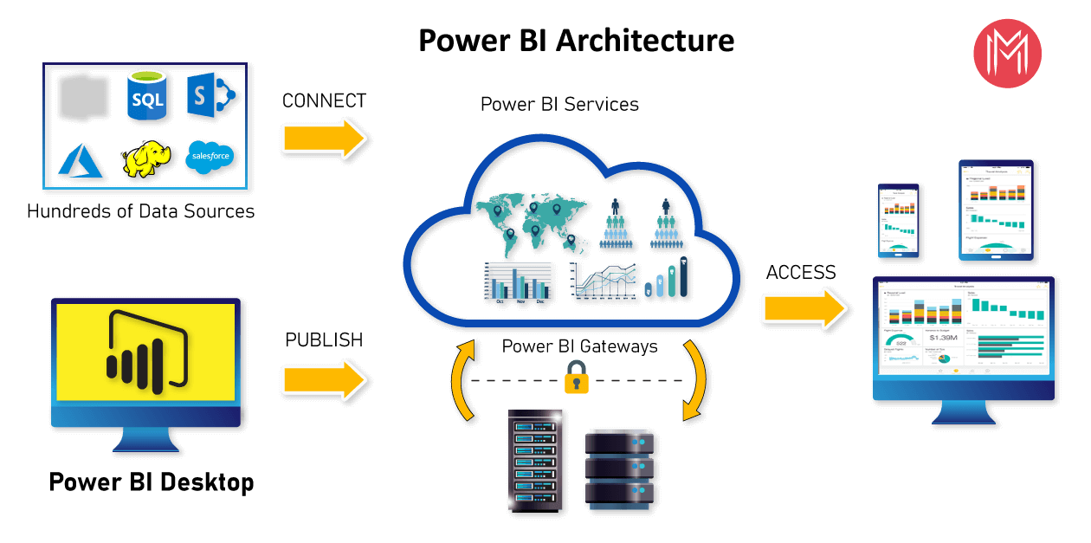

PowerBi Server is internally managed by the multiple server processes.

**1. Data Sources**

An important component of Power BI is its vast range of data sources. You can import data from files in your system, cloud-based online data sources or connect directly to live connections. If you import from data on-premise or online services there is a limit of 1 GB. Some commonly used data sources in Power BI are:

* Excel
* Text/CSV
* XML

**2) PowerBi Desktop:-**

Power BI Desktop is a client-side tool known as a companion development and authoring tool. This desktop-based software is loaded with tools and functionalities to connect to data sources, transform data, data modeling and creating reports.

|  |
| --- |
| 1. **PowerBi Services:-**   Power BI Service is a web-based platform from where you can share reports made on Power BI Desktop, collaborate with other users, and create dashboards.  It is available in three versions:   * Free version * Pro version * Premium version  1. **PowerBi Report Server:-**   The Power BI Report Server is similar to the Power BI Service. The only difference between these two is that Power BI Report Server is an on-premise platform. It is used by organizations who do not want to publish their reports on the cloud and are concerned about the security of their data.   1. **PowerBi Gateway:-**   This component is used to connect and access on-premise data in secured networks. Power BI Gateways are generally used in organizations where data is kept in security and watch. Gateways help to extract out such data through secure channels to Power BI platforms for analysis and reporting.     1. **PowerBi Mobile:-**   Power BI Mobile is a native Power BI application that runs on iOS, Android, and Windows mobile devices. For viewing reports and dashboards, these applications are used.   1. **PowerBi Embedded:-**   Power BI Embedded offers APIs which are used to embed visuals into custom applications. |

## PowerBi Process Flow

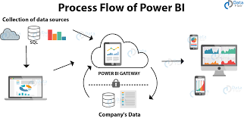

# 3. Deployment Description

## 3.1 Create a pipeline from the deployment:

To create a pipeline from the deployment pipelines tab, do the following:

* In Power BI service, from the navigation pane, select Deployment pipelines and then select Create pipeline.
* In the Create a deployment pipeline dialog box, enter a name and description for the pipeline, and select Create.

## 

## 3.2 Assign a workspace

After creating a pipeline, you need to add the content you want to manage to the pipeline. Adding content to the pipeline is done by assigning a workspace to the pipeline stage. You can assign a workspace to any stage.

## 3.3) Deploy to an empty stage

Any [Pro user](https://docs.microsoft.com/en-us/power-bi/enterprise/service-admin-purchasing-power-bi-pro) that's a member or admin in the source workspace, can deploy content to an empty stage (a stage that doesn't contain content).

The workspace must reside on a capacity for the deployment to be completed.

You can also use the [deployment pipelines REST APIs](https://docs.microsoft.com/en-us/rest/api/power-bi/pipelines) to programmatically perform deployments. For more information, see [Automate your deployment pipeline using APIs and DevOps](https://docs.microsoft.com/en-us/power-bi/create-reports/deployment-pipelines-automation).

If you already have a workspace that you'd like to use with a specific stage, instead of deploying you can [assign](https://docs.microsoft.com/en-us/power-bi/create-reports/deployment-pipelines-assign) that workspace to the appropriate stage.

## 3.4) Create deployment rules

When working in a deployment pipeline, different stages may have different configurations. For example, each stage can have different databases or different query parameters. The development stage might query sample data from the database, while the test and production stages query the entire database.

When you deploy content between pipeline stages, configuring deployment rules enables you to allow changes to content, while keeping some settings intact. For example, if you want a dataset in a production stage to point to a production database, you can define a rule for this. The rule is defined in the production stage, under the appropriate dataset. Once the rule is defined, content deployed from test to production, will inherit the value as defined in the deployment rule, and will always apply as long as the rule is unchanged and valid.

You can configure data source rules and parameter rules. The following table lists the type of Power BI items you can configure rules for, and the type of rule you can configure for each one.

## 